8-Week DBT Skills groups: September/October 2021
(All of the groups are on-line at this time)
Participant Information
Name:__________________________________________________ Date of Birth: _________________
Address: ______________________________________________________________________________
Phone number where a message can be left: _________________________________________________
Email ________________________________________________________________________________
 |  | Fee | # of participants | Total
Adults

You are new to DBT, or have not completed 3 or more skills groups:

 | Distress Tolerance (Tues, 6:30pm, 9/7/21 – 10/26/21) | $225
 | Emotional Regulation (Thur, 6:30pm, 9/9/21-10/28/21) | $225
You have completed 3 or more skills groups with Blue Door Psychotherapy, or have discussed this option with a Blue Door clinician:

 | Advanced DBT (Wed, 6pm, 9/8/21 – 12/27/21) | $225
Adolescents

 | Teen1: Distress Tolerance (Tues, 5:00 pm, 9/7/21 – 10/26/21 | $225
 | The Middle Path for Friends and family (Thur, 5:00 pm, 9/9/21-10/28/21) | $225

Signature of Client (or responsible party if client is a minor) Date

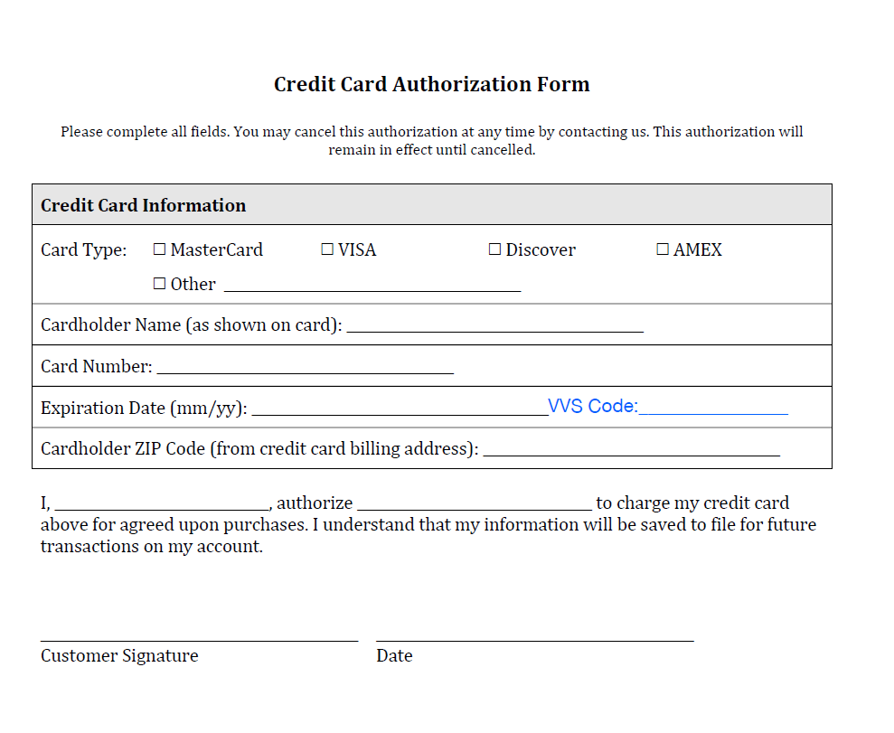
Email that is associated with the owner of this credit card:

__________________________________________

